Liferay Installation

In order to work with Liferay we have to install plugin in eclipse

There is number of ways to install Liferay plugins in eclipse

1. Download from url provided by url

Search in google **liferay eclipse plugin install**

I found the url in this page

<https://help.liferay.com/hc/en-us/articles/360017897772-Developing-Applications-with-Liferay-IDE>

Simplest one is to go eclipse tabs

Help -> Eclipse market place

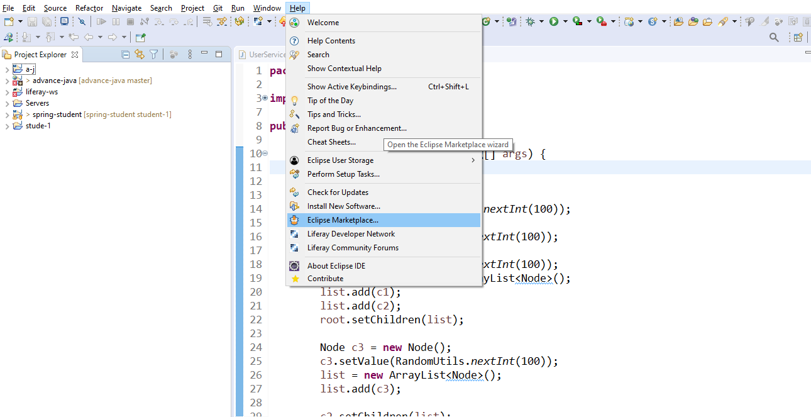

Search liferay and install it

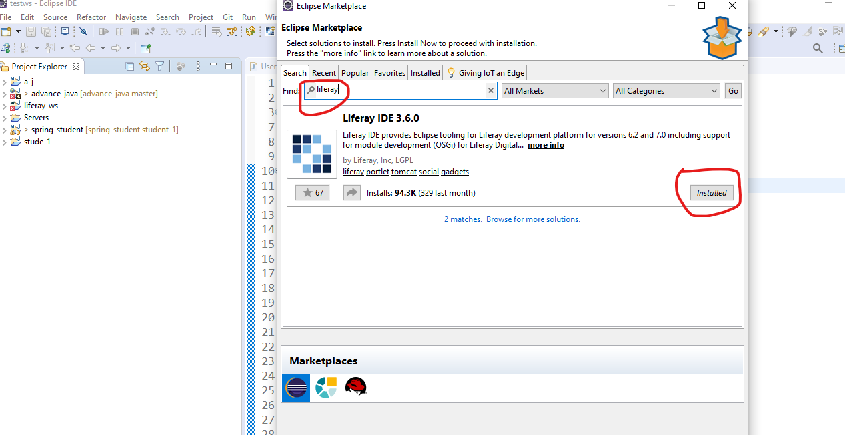

In my case it is already installed.

It will ask you to select some options and then will ask that do u want to install just click ok or yes and then restart eclipse.

If it is installed properly then we can see below plugins added to eclipse

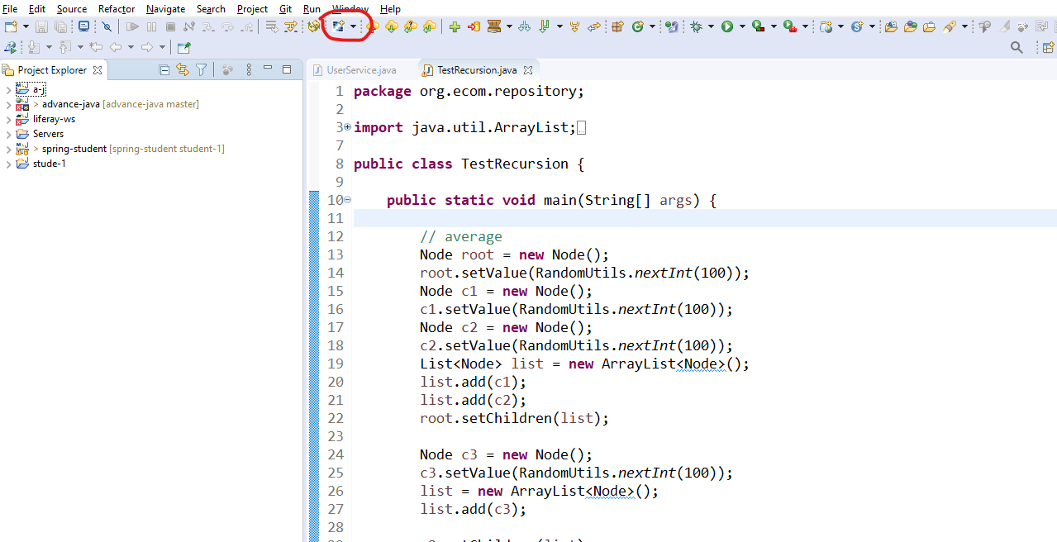

By default liferay plugin not available in eclipse.

In this process most of the times we face problem of missing dependencies.

To avoid this problem there is another way of installing liferay plugins in eclipse offline.

Search in google like this

download liferay 7.3 sourceforge (please change version)

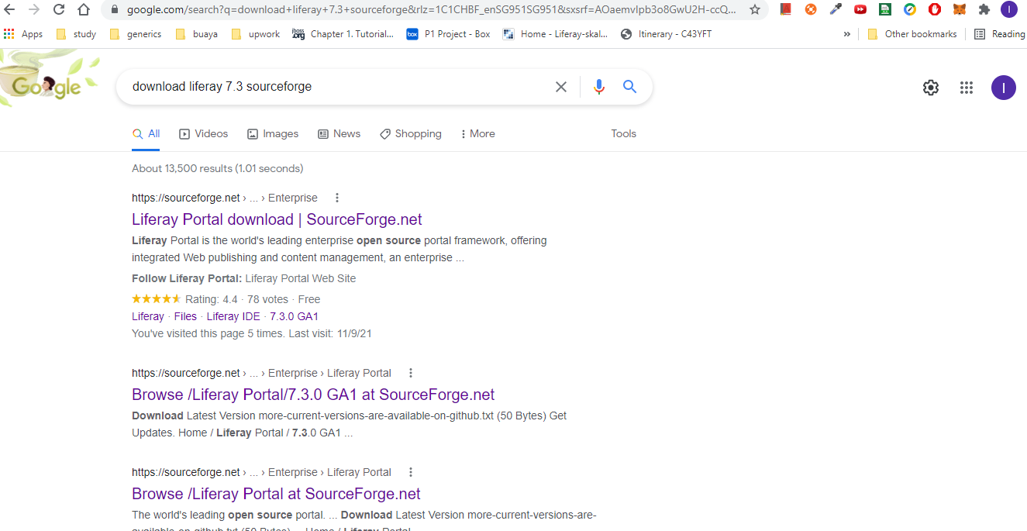

Open first link and go to Files tab in that page

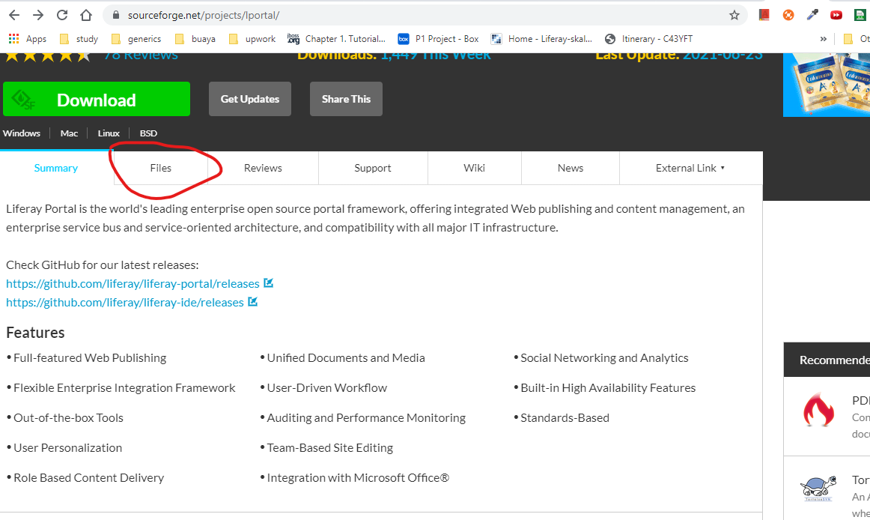

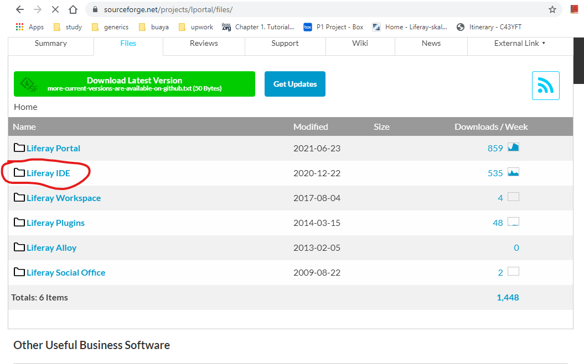

Click Liferay IDE link then download that version which is having most download count per week.

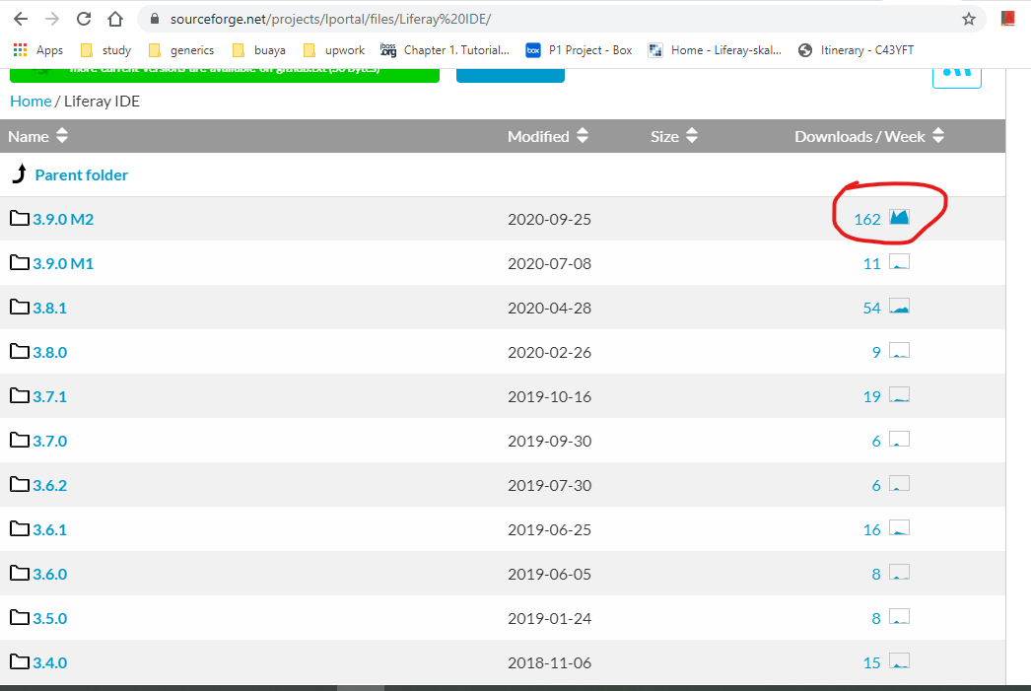

Go inside that folder and download the below one

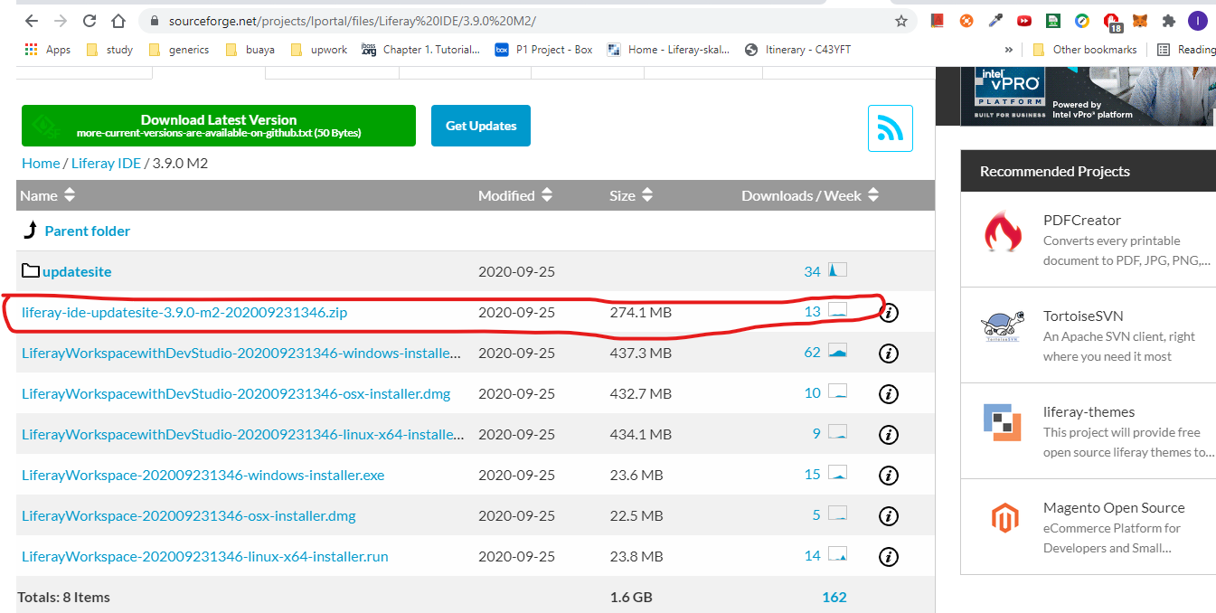

Once it is downloaded then go to eclipse tab

Help -> Install New Software

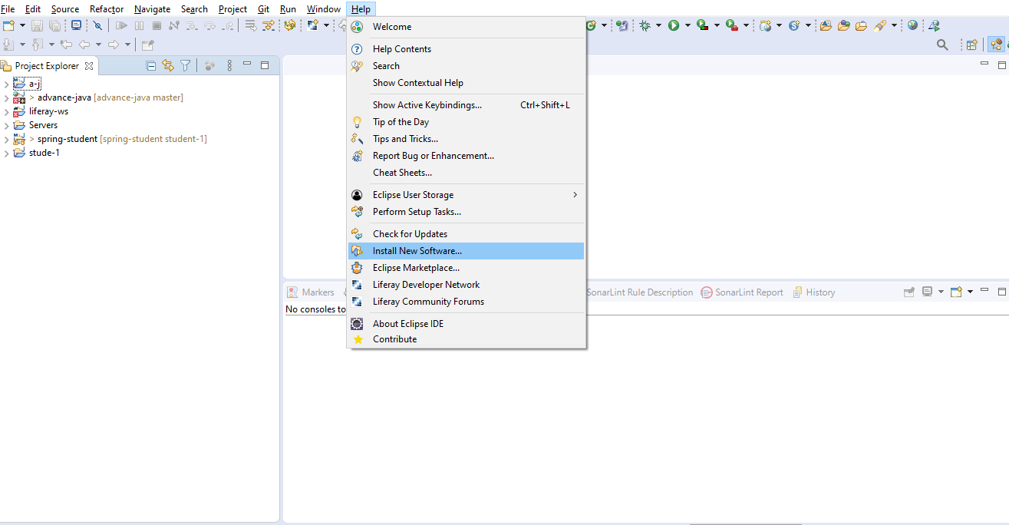

Click add button

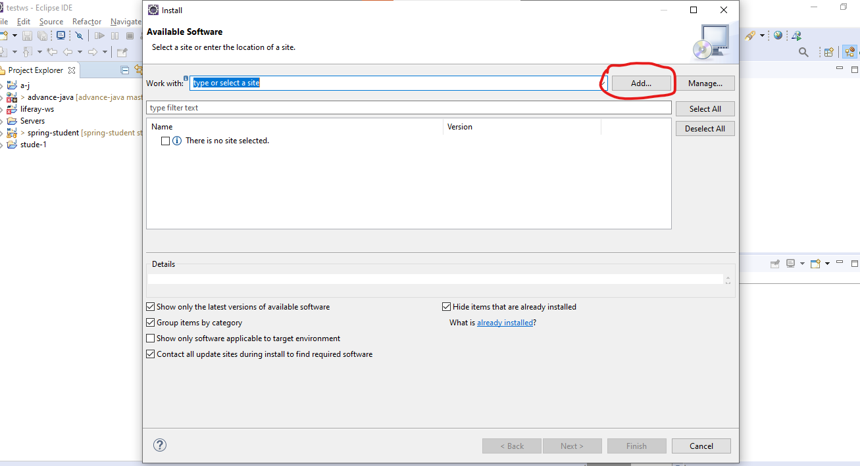

Then click archive

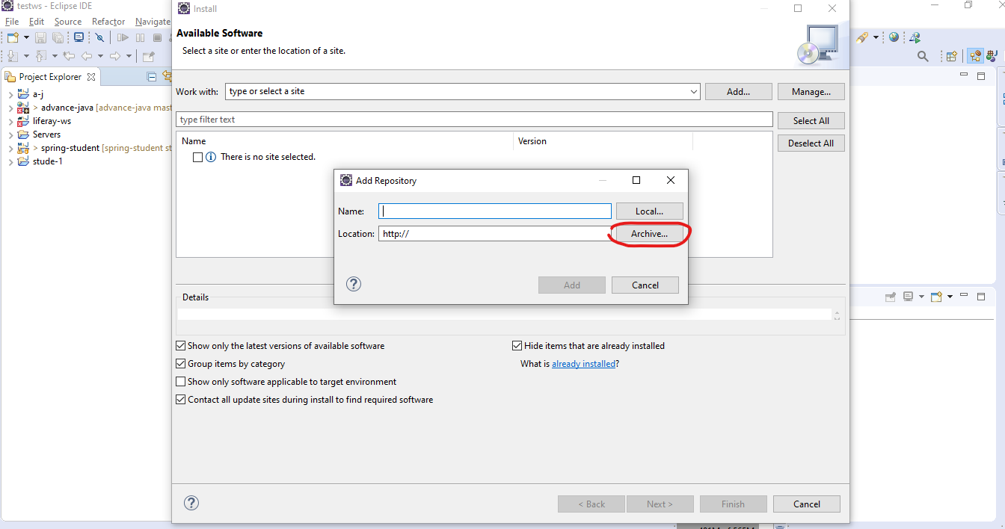

Then select that downloaded liferay ide zip that we did in above steps.

Then give some name like I gave here liferay-ide (it depends totally on developer)

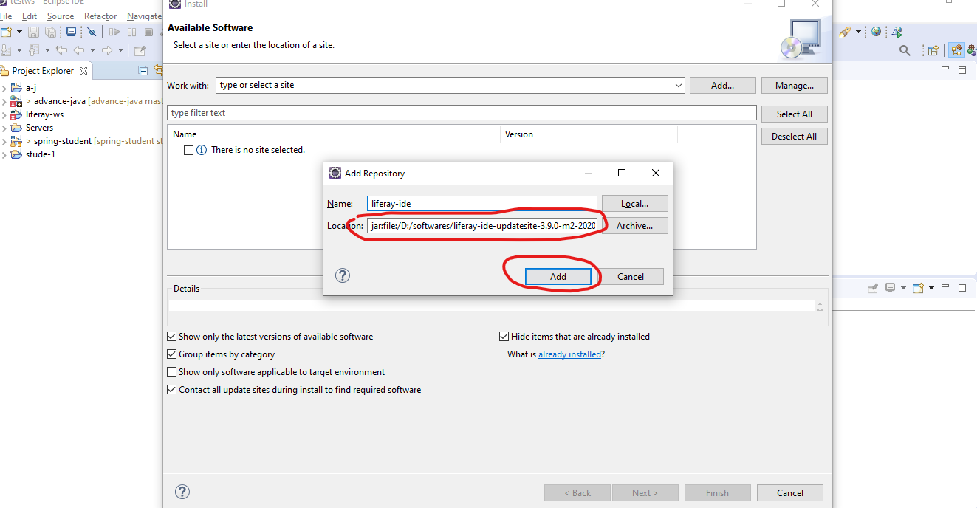

Then click add

Then select all

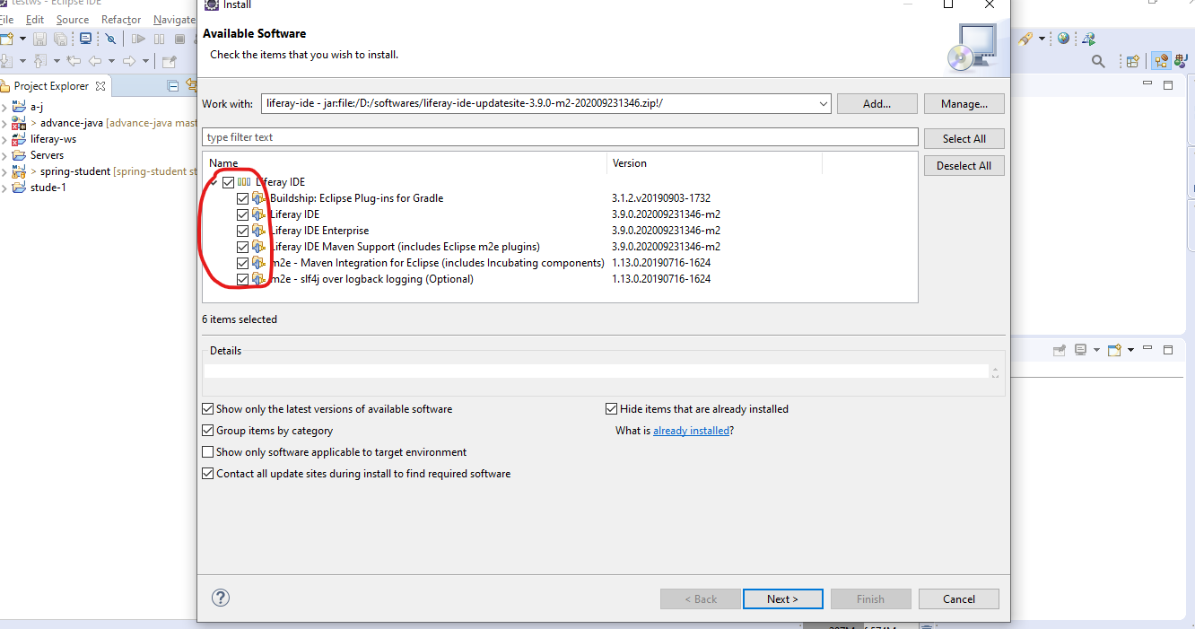

Then do next next

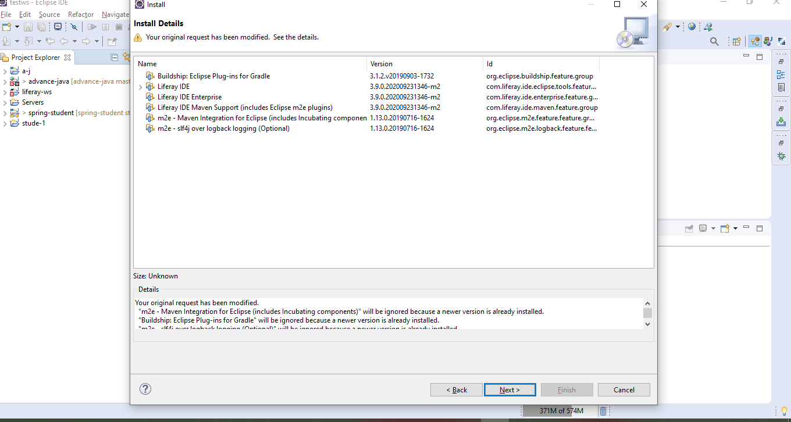

Again next

Accept the terms n conditions

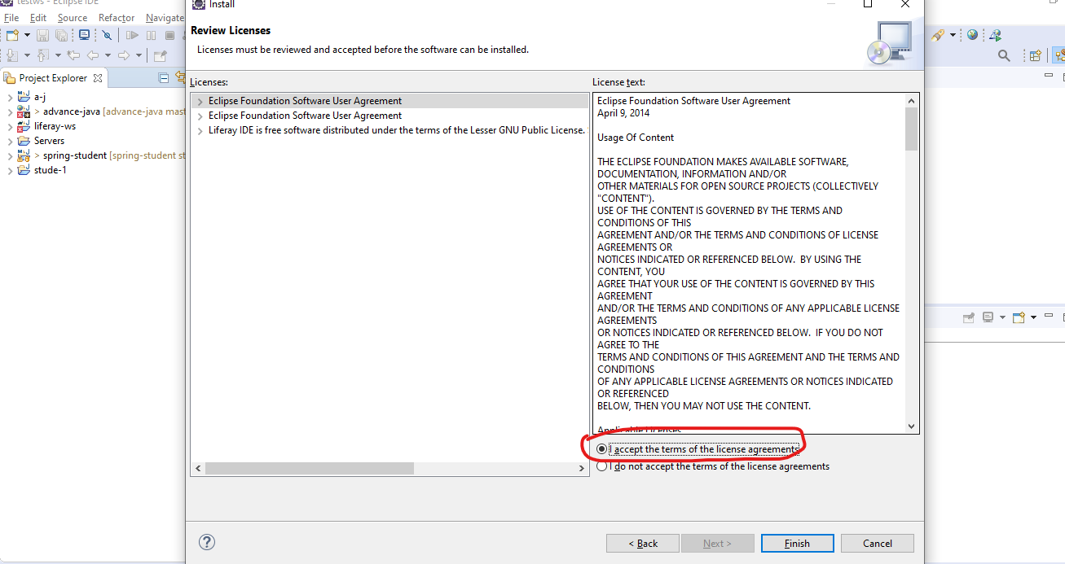

Then finish

It will take some time.

Then select Install anyway

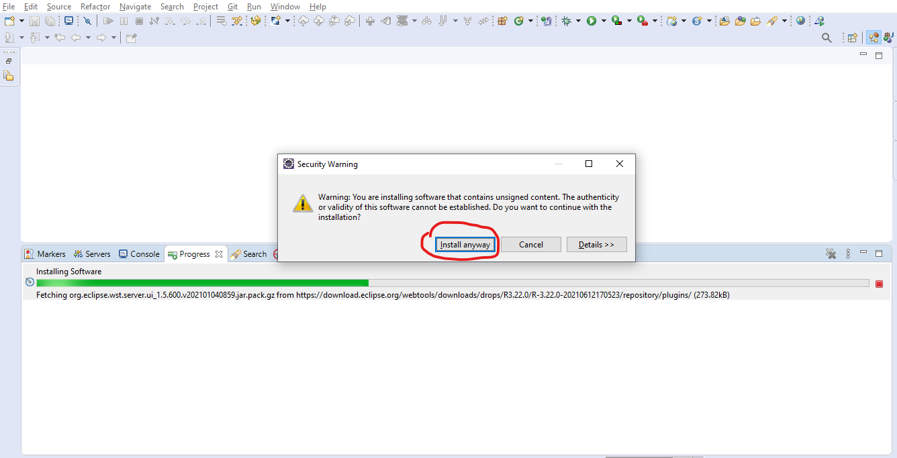

Then restart now

After restart we can see liferay plugins image in eclipse



Now we have to download liferay tomcat bundle.

Liferay tomcat bundle is a folder where all liferay out of box porltets (oob in short) are installed and it also contains tomcat server. If we want to use liferay then we should liferay tomcat bundle. In advance java we download tomcat separately and configure it. In Liferay case we should not do this else Liferay all oob(out of box) portlet will installed means we cannot run liferay.

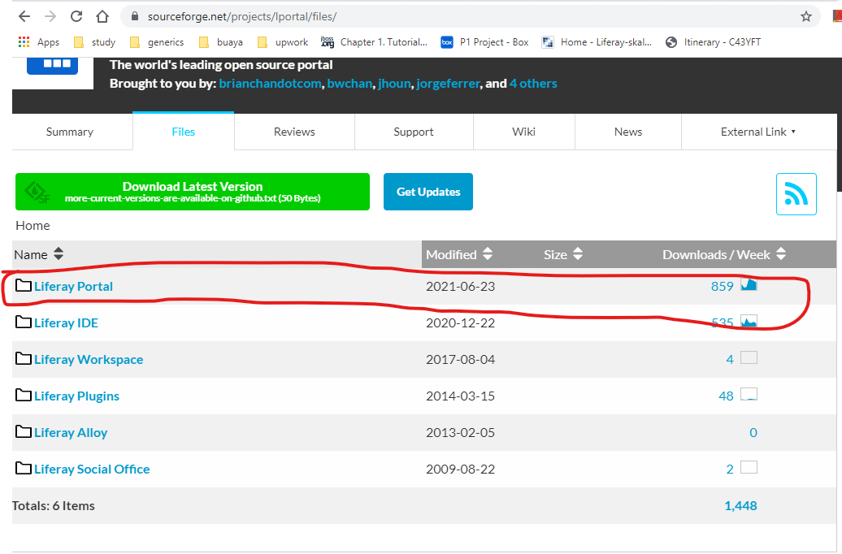

Go inside below folder

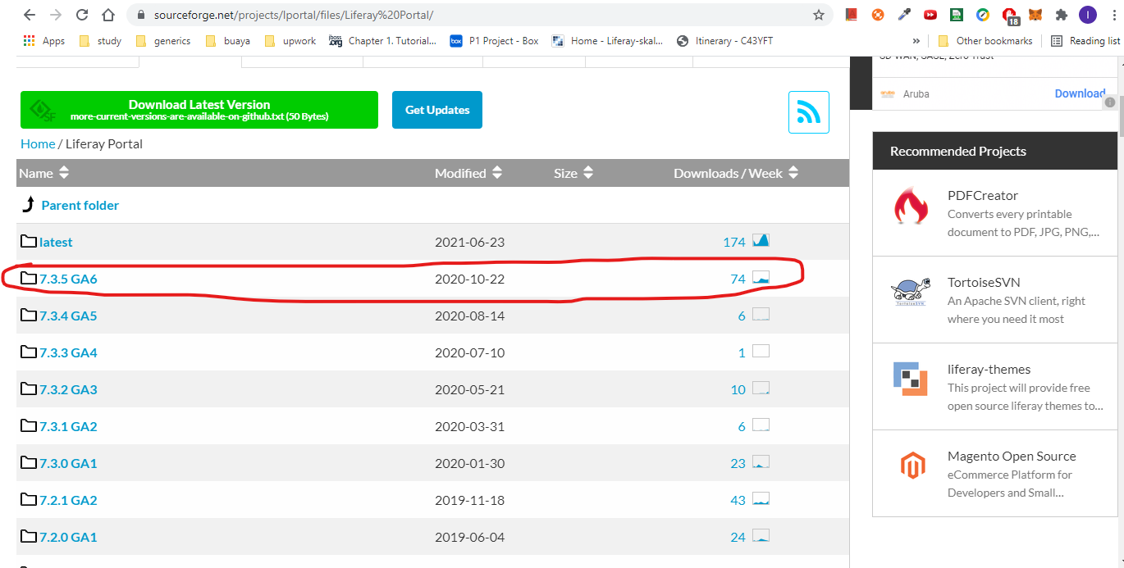

Then download

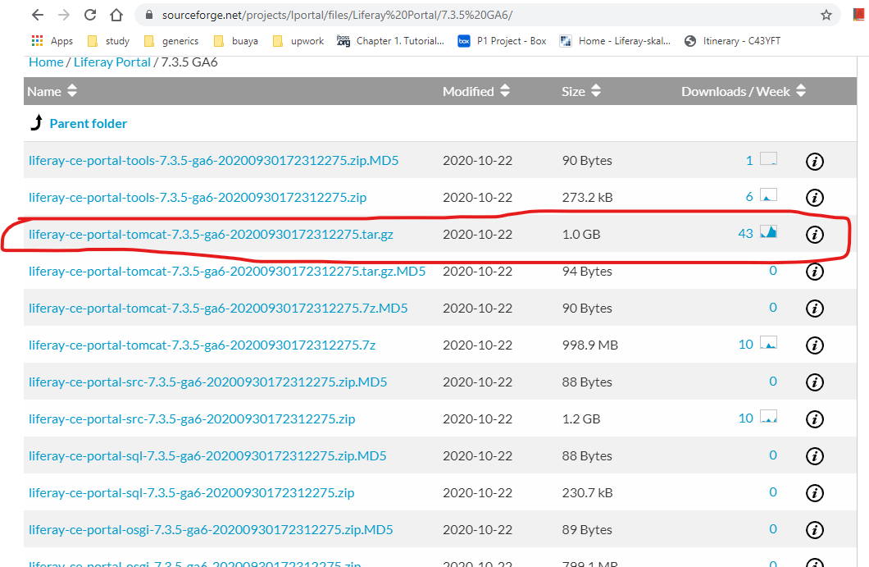

Once download then unzip

I am using 7-zip software to unzip

Our downloadable file name is : liferay-ce-portal-tomcat-7.3.5-ga6-20200930172312275.tar.gz

First we have to unzip this then we get new folder which again a zip folder namely : liferay-ce-portal-tomcat-7.3.5-ga6-20200930172312275.tar

Then we have to unzip this folder too and finally we will get liferay tomcat bundle

So final liferay tomcat bundler after unzip: liferay-ce-portal-7.3.5-ga6

We are using liferay ce (community version) version which is free of cost.

We have to version of liferay ce and ee.

Ee -> enterprise edition now from liferay 7 It is called dxp (digital experience).

Now we will install liferay server

Go to eclipse and select liferay server check below

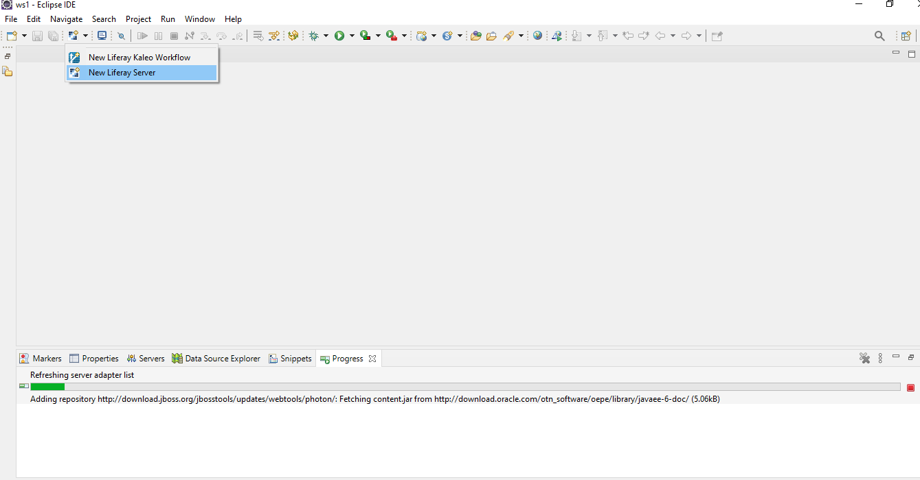

Then select Liferay, Inc. -> Liferay 7.x

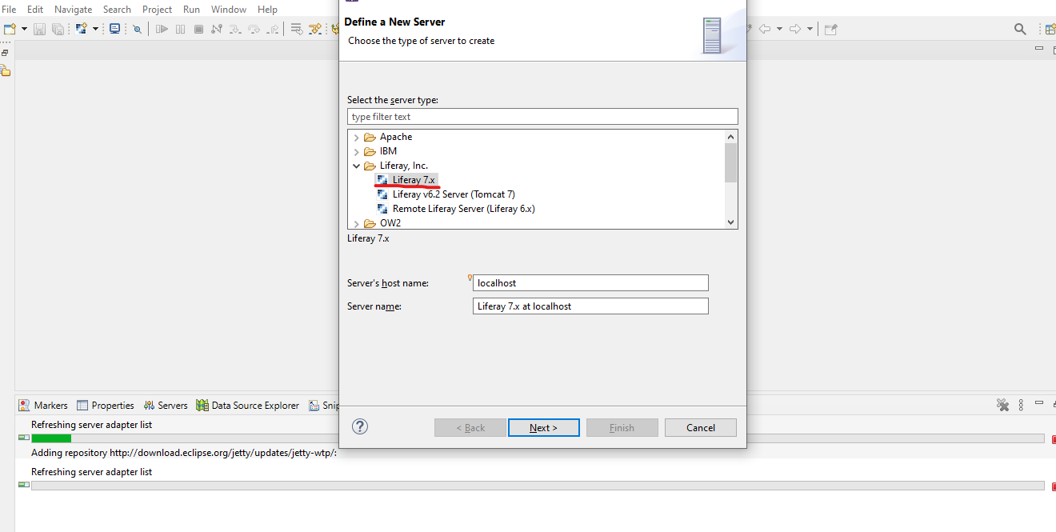

Then next

Now we have to select path of liferay tomcat folder

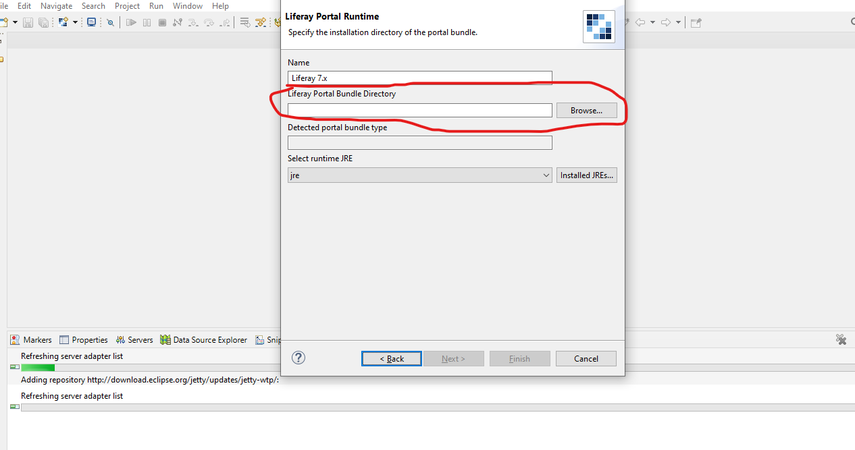

Click browse button

Then select folder of tomcat which is present inside Liferay tomcat bundle we just downloaded

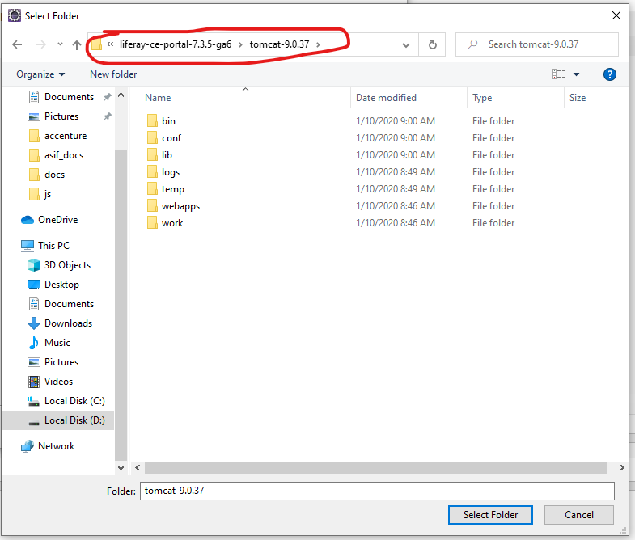

Then click select folder button then we can see tomcat bundle selected

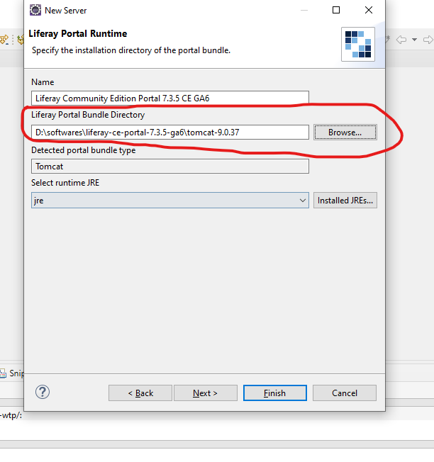

Then click installed JREs… button then select jdk folder of java that we are using or installed in our system.

In my case

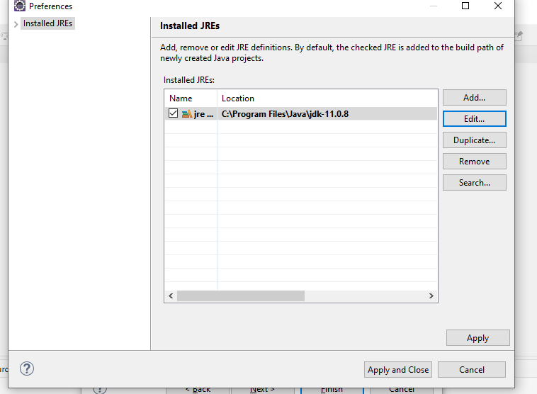

Then Apply and Close.

Then Finish

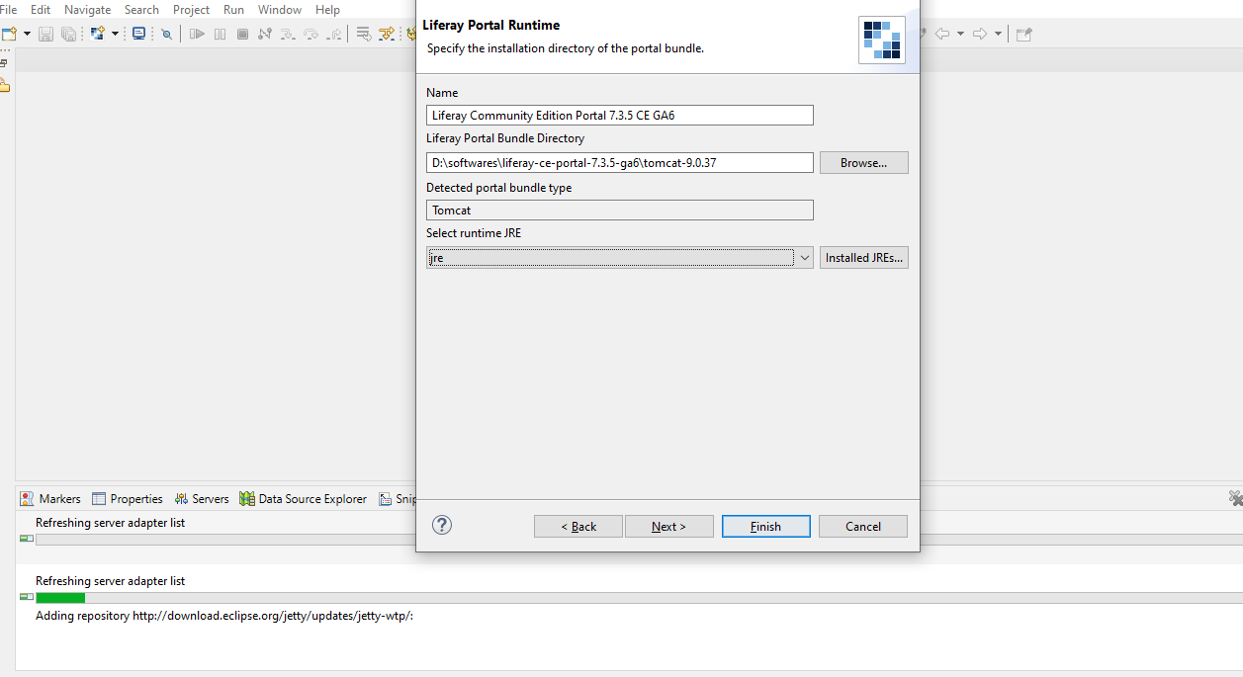

On clicking this button you can see progress of bar that liferay configuration is happening

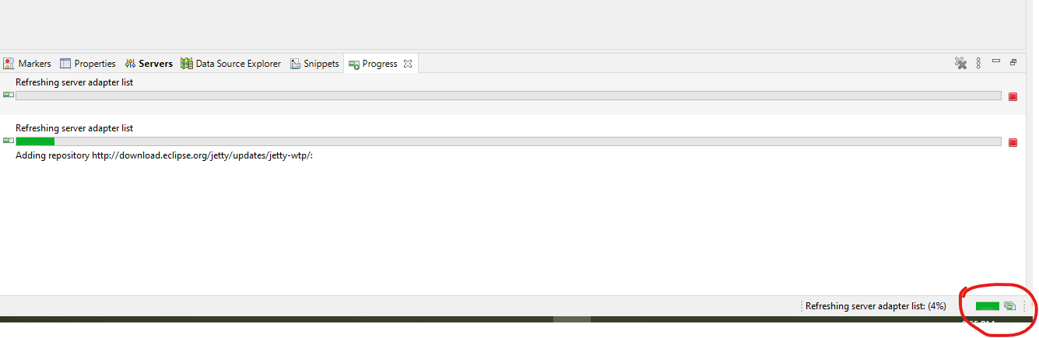

Once done we will go to server tab if not there then open from Window -> show view

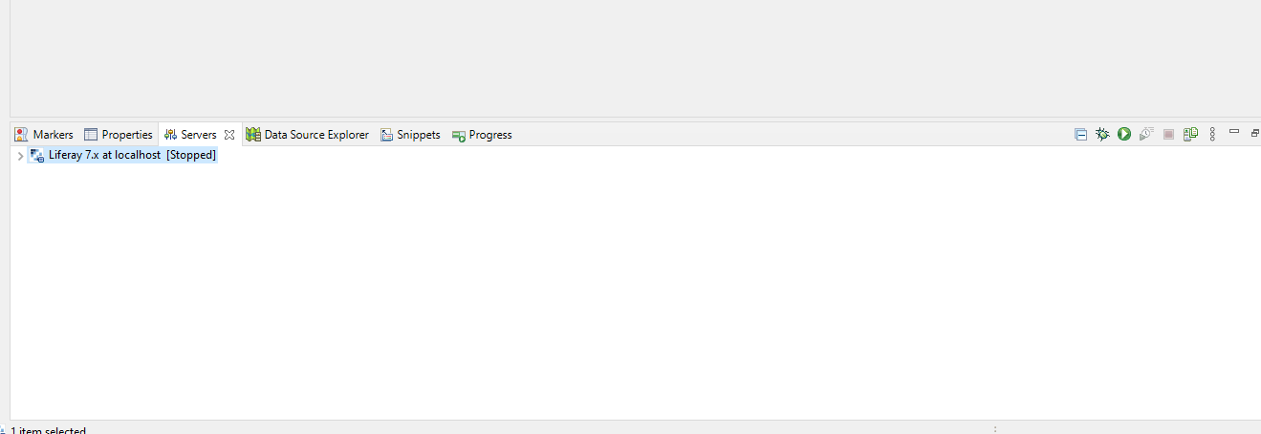

Now open mysql workbench and create new database

create database lportalst1;

I gave name lportalst1.

If you are running two different liferay server then please create different database for each liferay server/instance. Don’t use same database for different Liferay server.

Once database created we have to start our server.

First time when we start our server then we wouldn’t provide db configuration. We can but we don’t.

Once server start it will ask database connection option then we will provide the connection from browser. It is easy way to do database connection. But our database should be ready before we try to do connection else it will through exception at server start time.

We have to double click on server then server setting page will open and we will increase Timeouts – start time

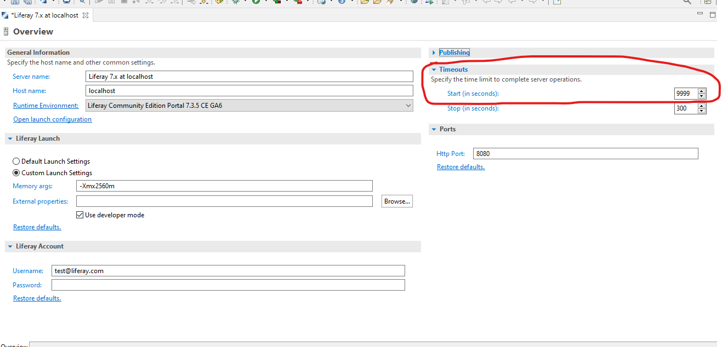

I created database, now I will start server.

If we do not configure database in liferay then by default it used hypersonic server which is not favourable.

Do NOT use Hypersonic in production. Hypersonic is an embedded database useful for development and demonstration purposes. The database settings can be changed in portal-ext.properties.

At server start time you can see this message.

Once server started then we have to enter localhost:8080 in browser

Then this page will appear.

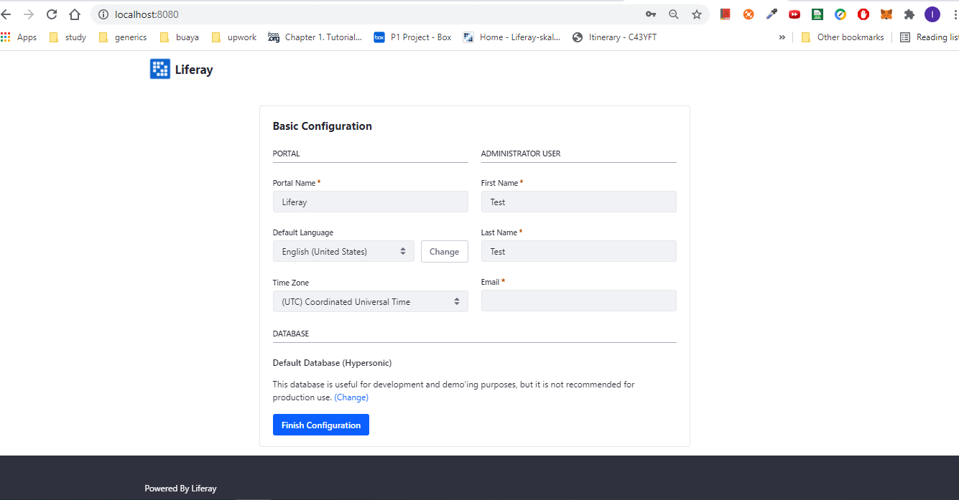

Now I want to connect my Liferay with database we have to click on change link

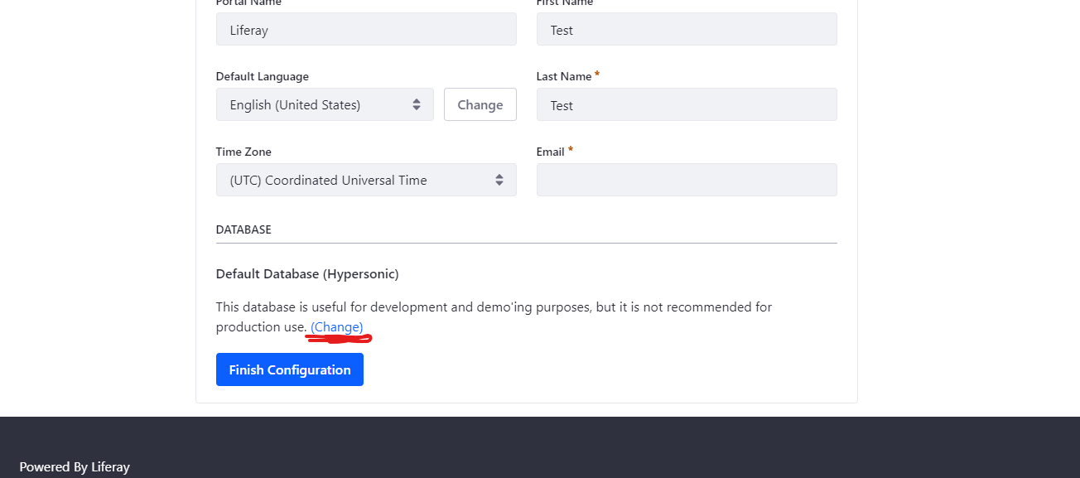

Once we click change link then below section will appear

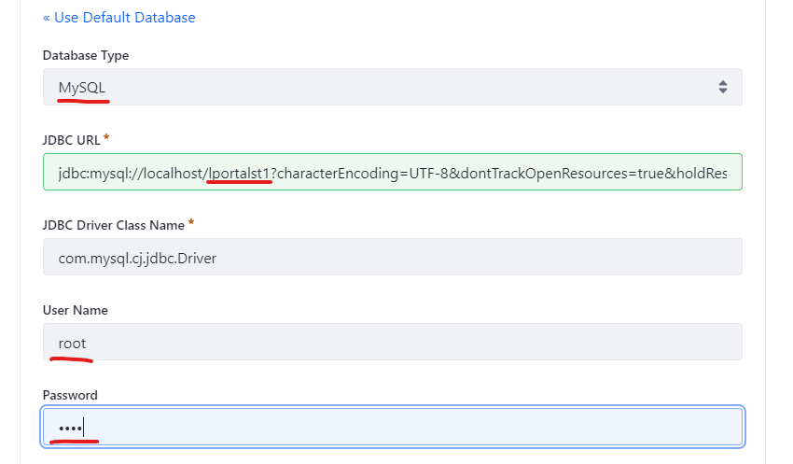

Here wherever I did red underline we have to change there

First we will select mysql database from first dropdown. Then we have to give our database name in JDB URL field as I did underline then provide db username and password and then click Finish Configuration button.

Please use same configuration following the page

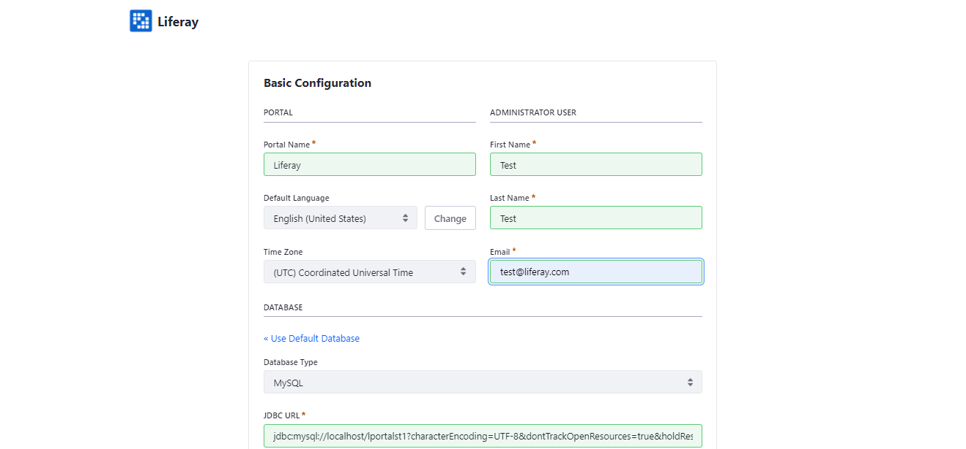

Once we are done with finish configuration then below page will appear.

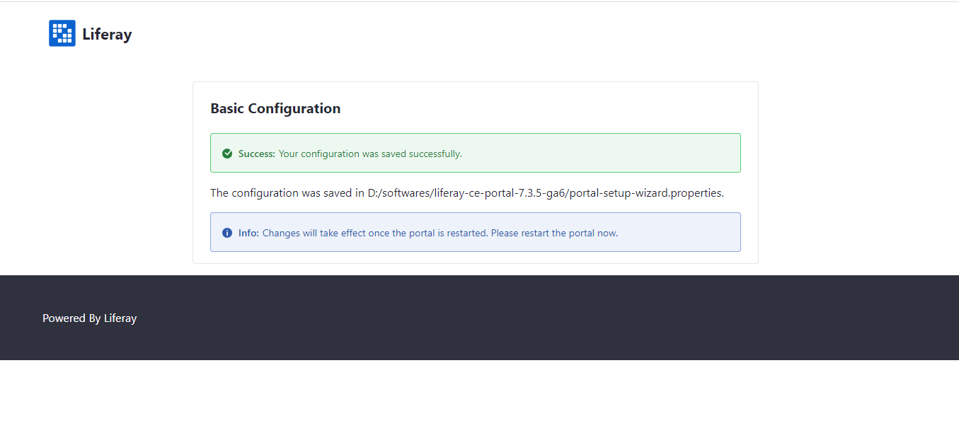

Then we have to restart our server to change take effect.

This time server would take more time to restart because our liferay will create around 180 approx number of tables.

If database connection ok means our database working fine and all liferay connected with mysql then we can see these messages in our eclipse console.

[main][DialectDetector:159] Using dialect org.hibernate.dialect.MySQLDialect for MySQL 8.0

2021-09-17 13:31:38.546 INFO [main][DBInitUtil:173] Create tables and populate with default data

Now again try localhosts:8080 then page will appear may be image would be different

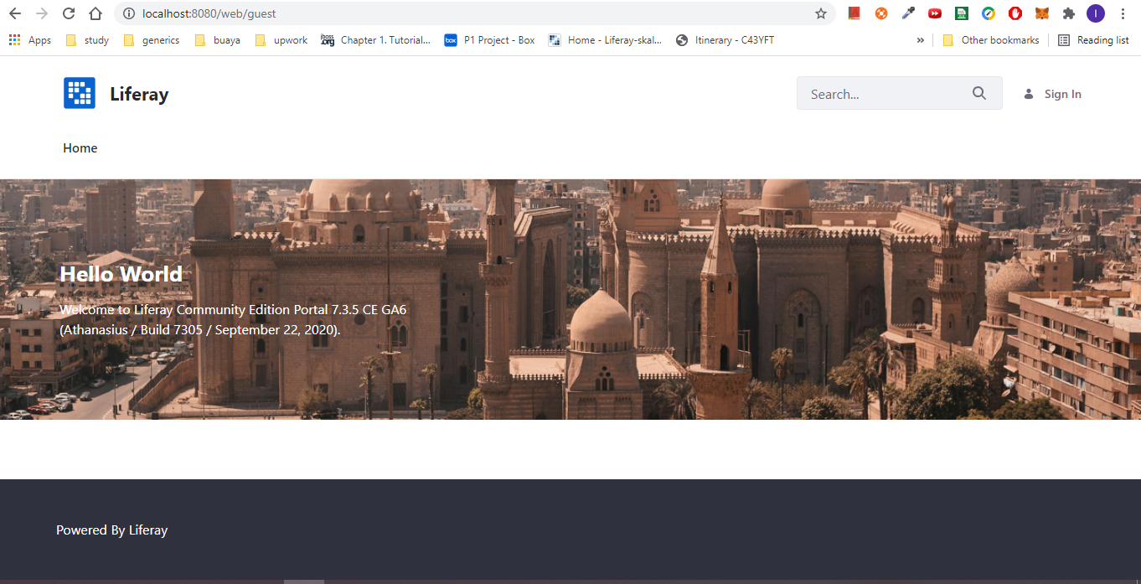

Then on right side top we have to click on sign in and provide

Email address: [test@liferay.com](mailto:test@liferay.com)

Password : test

Sign in

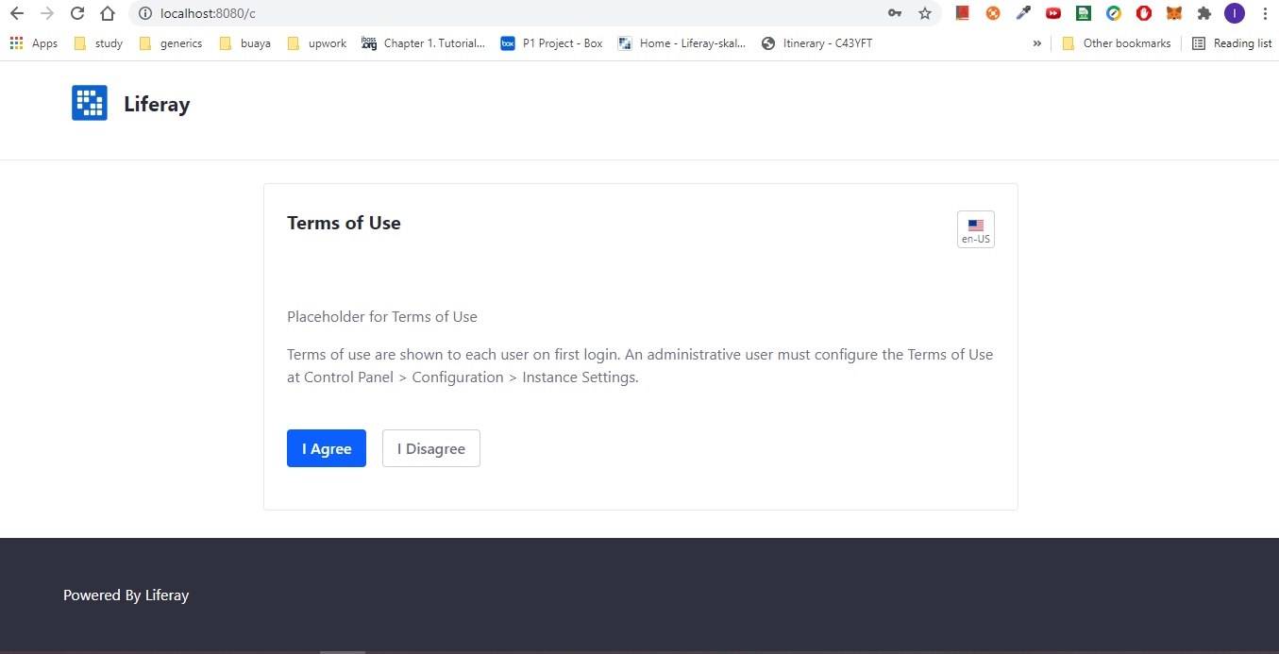

Select I Agree

Give any name

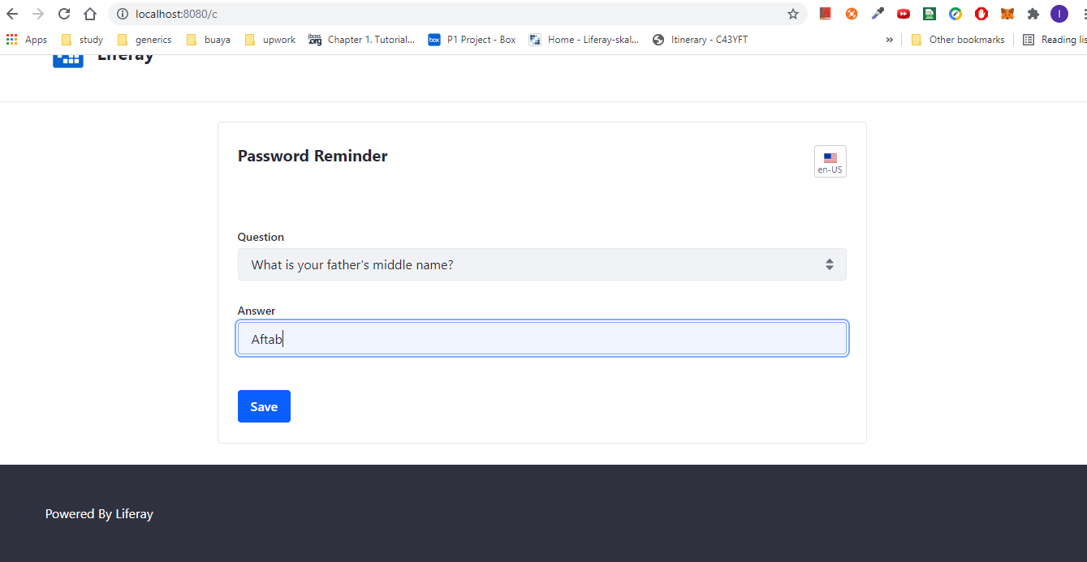

Then save

Then we are logged in using test, test

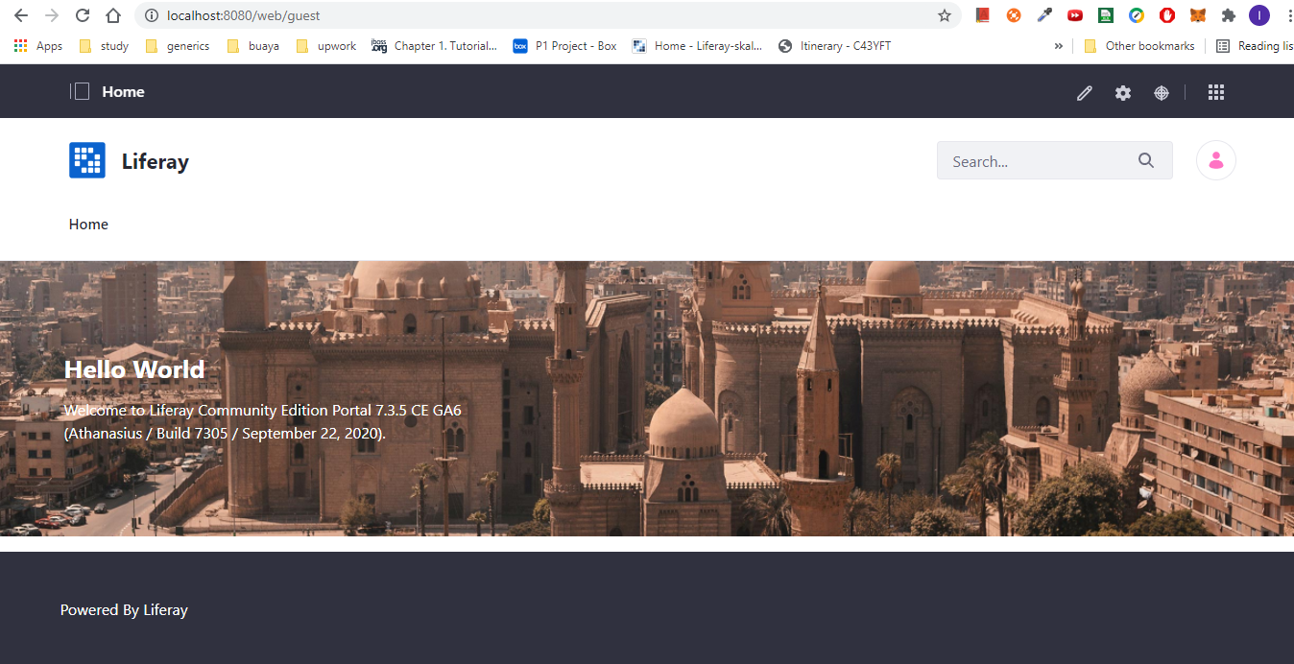

And liferay setup completed.

Now we have to create liferay workspace

File -> New -> Other… -> then type liferay

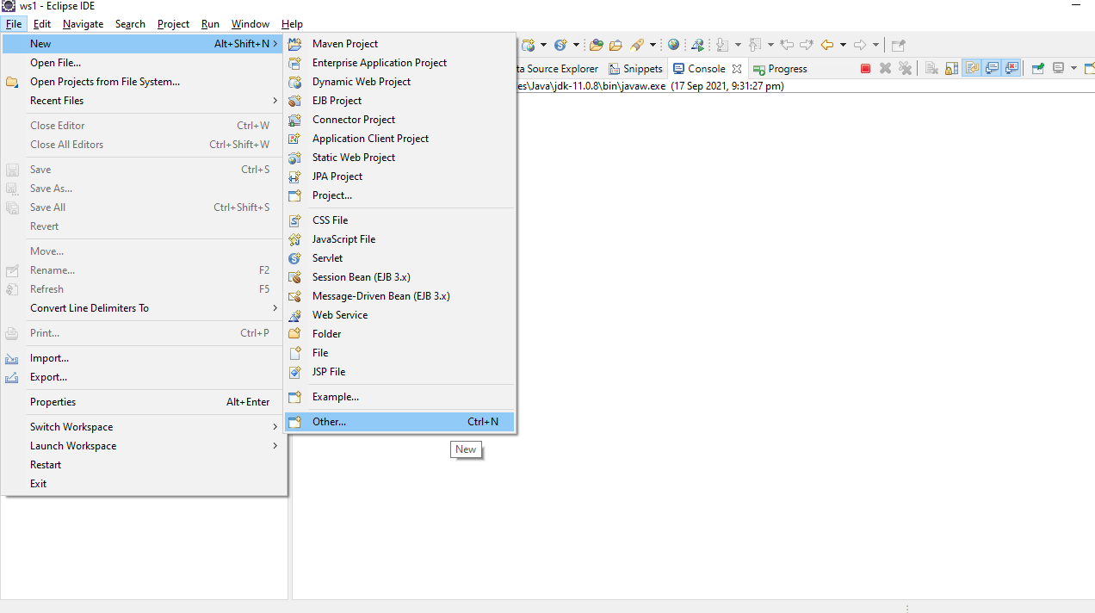

Select Liferay Workspace project

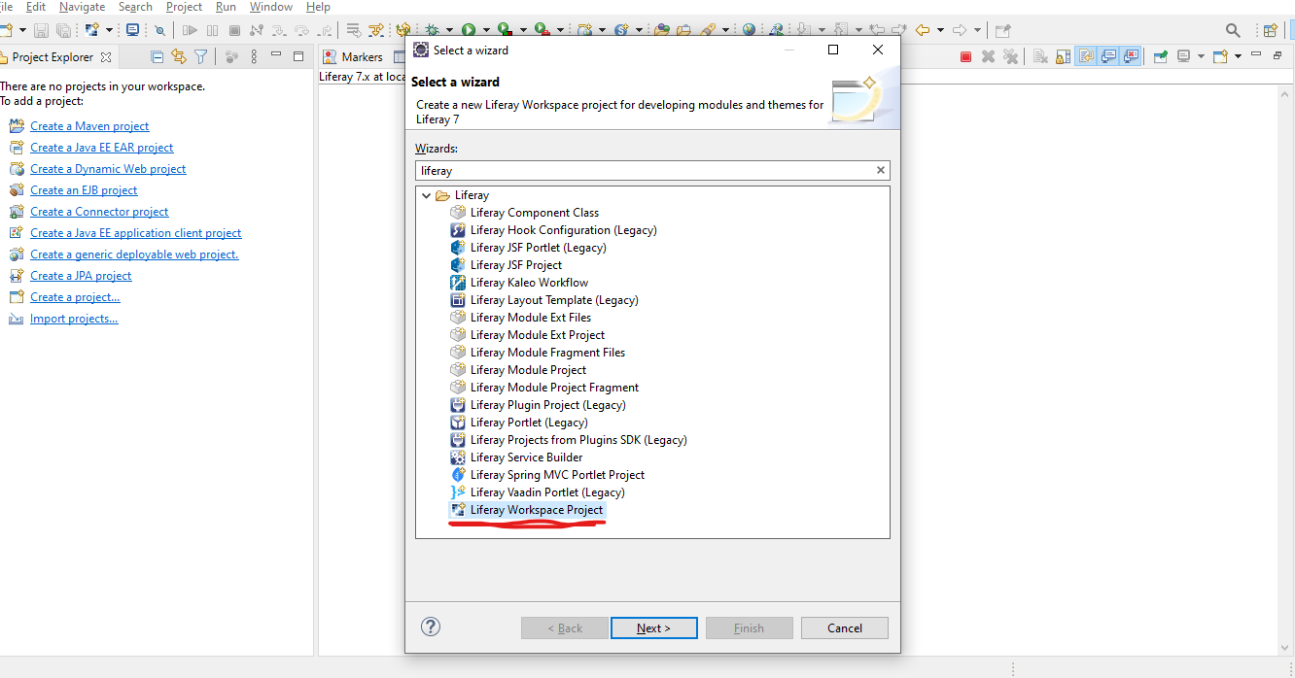

Then Next

Give workspace any name

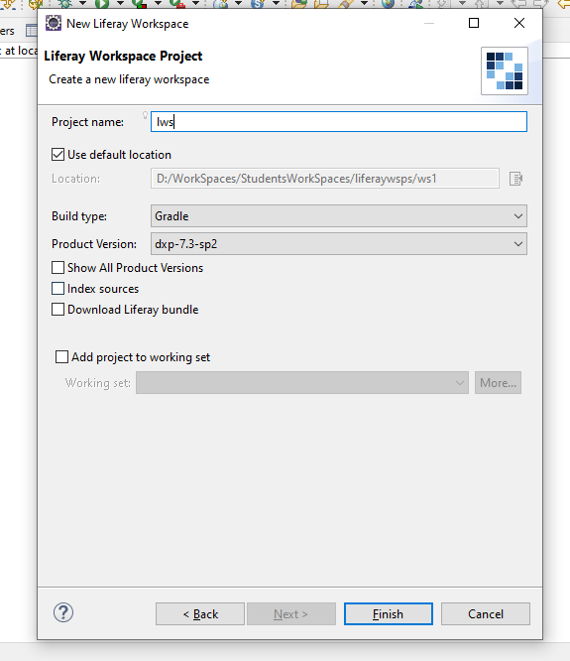

Then Finish

For first time may be it will take some times.

Select Open Perspective

